**Block 2 Challenge Proposal**

1. Purpose
   * The purpose of this app will be to assist a person in setting up/building a team of pokemon that they wish to use when playing the game.
2. Audience
   * The audience for this type of app will be those that enjoy playing the pokemon game, who wish to decide which pokemon they want on their team, considering the game only allows for 6 pokemon on a team at one time, and there are 150 pokemon to choose from (or more, depending on the version of the game you play)
3. Data Sources
   * External API – PokeAPI v2, for getting pokemon data and images
   * localStorage – for saving the pokemon team that the user has built
4. Initial Module list
   * index.js
   * teamBuild.js
   * apiConnect.js
   * pokemonSearch.js
5. Wireframes
   * Home (Small view) - <https://wireframe.cc/GFpU0m>
   * Home (Large view) - <https://wireframe.cc/H1DUBv>
   * My Team (Small view) - <https://wireframe.cc/VBt7b6>
   * My Team (Large view) - <https://wireframe.cc/8PqSXH>
   * Pokemon Search (Small view) - <https://wireframe.cc/aUTuHL>
   * Pokemon Search (Large view) - <https://wireframe.cc/KiKfuf>

1. Typography / Colors
   * Typography
     1. Headings – Pokemon Solid (<https://www.cdnfonts.com/pokemon-solid.font>)
     2. Everything else – Roboto (<https://fonts.google.com/specimen/Roboto?query=roboto>)
   * Colors

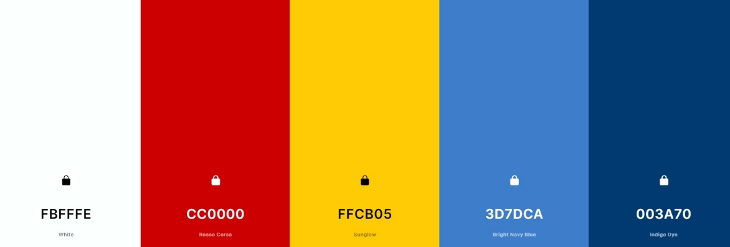

1. Schedule
   * Week 10
     1. Create HTML pages for different views
     2. Apply typography and colors
     3. Create all needed HTML elements (without styling them)
   * Week 11
     1. Style the created elements. Get the 3 pages looking like wireframes.
   * Week 12
     1. Write code to connect to PokeAPI and test connection
     2. Set up local storage and test that it is saving data
     3. Write code to generate list of pokemon based on user’s search parameters (Pokemon Search page)
     4. Write code to implement adding pokemon names to localstorage (My Team page)
   * Week 13
     1. Write code to implement delete functionality of localstorage data (for the My Team page)
     2. Add error handling to catch errors if user inputs incorrect data in the search field.
     3. Add animation for pokeball to move across the web page (maybe just the home web page)
   * Week 14
     1. Final testing for bugs. Dry run through entire app.
     2. Check that everything works properly (API, Routes, localStorage, etc.)
     3. Submit project

**\*Note\*** - If any time is left after completing a certain week’s tasks, I will begin working on the following week’s tasks to get ahead.